Tugas Pemrograman Dasar Web 3
Nama : Vincent
NIM: A12.2026.07556 (RPL)
Link Github:
Wireframe:
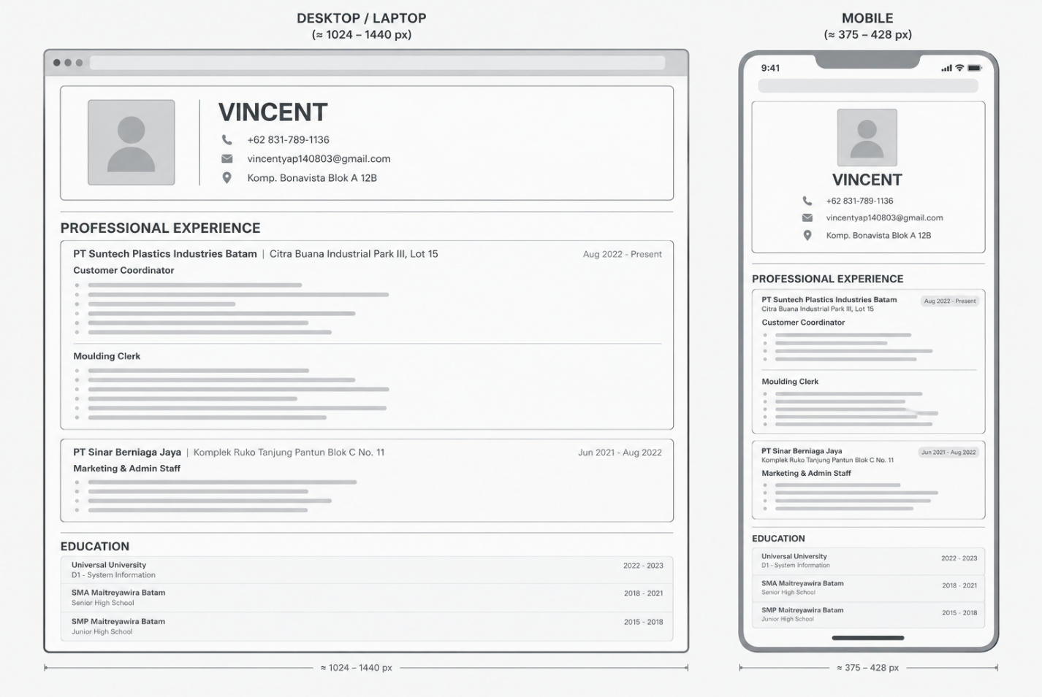
HTML & Bootstrap:
<!DOCTYPE html>
<html lang="en">
<head>
<title>CV Vincent A12.2026.07556</title>

<meta name="viewport" content="width=device-width, initial-scale=1">

<!-- Link ke Bootstrap -->
<link rel="stylesheet" href="./bootstrap-5.0.2-dist/css/bootstrap.min.css">

<!-- Link ke CSS -->
<link rel="stylesheet" href="style.css">

<style>
@import url('https://fonts.googleapis.com/css2?family=Roboto:ital,wght@0,100..900;1,100..900&display=swap');

@import url('https://fonts.googleapis.com/css2?family=Poppins:ital,wght@0,100;0,200;0,300;0,400;0,500;0,600;0,700;0,800;0,900;1,100;1,200;1,300;1,400;1,500;1,600;1,700;1,800;1,900&family=Roboto:ital,wght@0,100..900;1,100..900&display=swap');
</style>
</head>

<body>
<div class="container bg-color rounded-3">
<!-- Judul CV -->
<div class="title1 rounded-3">

<!-- Bagian foto -->
<div class="image-div"><img class="CV-image" src="CV-image.jpeg" alt="CV-image"></div>

<!-- Garis pemisah -->
<div class="border-image"></div>

<!-- Bagian nama dan kontak -->
<div>
<p class="name">VINCENT</p>
<div class="contact">
<div>
<span><img class="CV-icon" src="telp-logo.png" alt="telp-logo"></span>
<span>+62 831-789-1136</span>
</div>

<div>
<span><img class="CV-icon" src="email-logo.png" alt="email-logo"></span>
<a href="https://mail.google.com/mail/?view=cm&fs=1&to=vincentyap140803@gmail.com" target="_blank" class="email-link">vincentyap140803@gmail.com</a>
</div>

<div>
<span><img class="CV-icon" src="addrs-logo.png" alt="addrs-logo"></span>
<span>Komp. Bonavista Blok A 12B</span>
</div>
</div>
</div>
</div>

<!-- Garis pemisah -->
<div class="border-section"></div>

<!-- Pengalaman kerja -->
<h1 class="h3 fw-bold mb-3">PROFESSIONAL EXPERIENCE</h1>

<!-- Pengalaman kerja 1 -->
<div class="job p-3 pb-0 mb-3 rounded-3">

<!-- Nama perusahaan & lama kerja -->
<div class="company-name-date">
<div>
<h3 class="company-name">
PT Suntech Plastics Industries Batam | Citra Buana Industrial Park III, Lot 15
</h3>
</div>

<div class="date">
<h3>Aug 2022 - Present</h3>
</div>
</div>

<table>
<!-- Jabatan -->
<tr>
<th class="job-title">
Customer Coordinator
</th>
</tr>

<!-- Deskripsi pekerjaan -->
<tr>
<td>&bull; Handle PO from customer and update the PO balance.</td>
</tr>
<tr>
<td>
&bull; Calculate the material and packaging consumption based on PO and forecast and monitor the production output.
</td>
</tr>
<tr>
<td>&bull; Coordinate with customer to schedule the delivery of products.</td>
</tr>
<tr>
<td>&bull; Report product shortages and ask to set up mold to meet the delivery demand.</td>
</tr>
<tr>
<td>&bull; Create a report for product stock, material stock, demand forecast, and balance PO.</td>
</tr>
<tr>
<td>&bull; Update monthly delivery performance and tooling life report.</td>
</tr>
</table>

<table>
<!-- Jabatan -->
<tr>
<th class="job-title">
Moulding Clerk
</th>
</tr>

<!-- Deskripsi pekerjaan -->
<tr>
<td>&bull; Calculate and report daily outputs of each machines using MS Excel.</td>
</tr>
<tr>
<td>
&bull; Create a monthly production summary report using Excel’s power query and using pivot table to create an analytic report.
</td>
</tr>
<tr>
<td>
&bull; Key-in daily “Line Non-Conformance Report” using MS Excel and create the weekly LNC summary report using power query and pivot table.
</td>
</tr>
<tr>
<td>&bull; Assist in writing down daily schedules for mold changes and sending set up forms to planning dept.</td>
</tr>
<tr>
<td>&bull; Prepare, manage stock, and order supplies to support production needs (e.g. gloves, protection tapes).</td>
</tr>
<tr>
<td>&bull; Receive new SOP from HOD and creating the official document using MS Excel.</td>
</tr>
<tr>
<td>&bull; Update operator/assistant leader/leader manpower and replacement data.</td>
</tr>
</table>
</div>

<!-- Pengalaman kerja 2 -->
<div class="job p-3 pb-0 mb-3 rounded-3">

<!-- Nama perusahaan & lama kerja -->
<div class="company-name-date">
<div>
<h3 class="company-name">
PT Sinar Berniaga Jaya | Komplek Ruko Tanjung Pantun Blok C No. 11
</h3>
</div>

<div class="date">
<h3>Jun 2021 - Aug 2022</h3>
</div>
</div>

<table>
<!-- Jabatan -->
<tr>
<th class="job-title">
Marketing & Admin Staff
</th>
</tr>

<!-- Deskripsi pekerjaan -->
<tr>
<td>&bull; Meet new customers and source products based on their requirements.</td>
</tr>
<tr>
<td>&bull; Create and send quotations to customers.</td>
</tr>
<tr>
<td>&bull; Handle item inventory and inform suppliers of the need to purchase products.</td>
</tr>
<tr>
<td>&bull; Create a simple business website to showcase and promote products and to ease data management.</td>
</tr>
</table>
</div>

<!-- Garis pemisah -->
<div class="border-section"></div>

<!-- Pendidikan -->
<div>
<h1 class="education-title h3 fw-bold mb-3">EDUCATION</h1>

<div class="education-box rounded-3">
<table class="education-table">
<tr>
<th></th>
<th></th>
</tr>

<!-- Deskripsi pekerjaan -->
<tr>
<td class="edu-list"><strong>Universal University</strong></td>
<td class="edu-list edu-date"><strong>2022 - 2023</strong></td>
</tr>
<tr>
<td>D1 - System Information</td>
</tr>
<tr>
<td class="edu-list"><strong>SMA Maitreyawira Batam</strong></td>
<td class="edu-list edu-date"><strong>2018 - 2021</strong></td>
</tr>
<tr class="edu-list">
<td class="edu-list"><strong>SMP Maitreyawira Batam</strong></td>
<td class="edu-list edu-date"><strong>2015 - 2018</strong></td>
</tr>
</table>
</div>
</div>
</body>
</html>
CSS:
:root{
--primary: #214e3d;
--primary-light: #429273;
--primary-dark: #17382c;
--job: #534f33;
--bg-html: #e6e9d4;
--CV-bg: #dbe9d4;
--text: #26332d;
--gray:#c5d3cc;
--black: #000000;
--h2: #97aedf;
}

*{
box-sizing: border-box;
margin: 0;
padding: 0;
}

body{
font-family: Poppins, Roboto, Arial, sans-serif;
background-color: var(--bg-html);
color: var(--text);
padding: 30px 20px;
}

.bg-color{
width: 100%;
max-width: 1150px;
margin: 0 auto;
padding: 30px;
background-color: var(--CV-bg);
border: 2px solid var(--black);
}

.title1{
display: grid;
grid-template-columns: 200px 2px minmax(0, 1fr);
align-items: center;
gap: 25px;
padding: 18px;
background-color: var(--gray);
border: 2px solid var(--primary-dark);
}

.image-div{
width: 200px;
height: 200px;
}

.CV-image{
width: 100%;
height: 100%;
object-fit: cover;
border: 2px solid var(--primary-dark);
border-radius: 8px;
}

.border-image{
align-self: stretch;
background-color: var(--primary-dark);
}

.name{
color: var(--primary);
font-size: clamp(32px, 4vw, 48px);
font-weight: 700;
line-height: 1.2;
margin-bottom: 10px;
}

.contact{
display: flex;
flex-direction: column;
gap: 6px;
font-size: 14px;
font-weight: 500;
}

.CV-icon{
width: 16px;
height: 16px;
margin-right: 8px;
object-fit: contain;
}

.email-link{
color: var(--primary);
text-decoration: none;
}

.email-link:hover{
text-decoration: underline;
color: var(--primary-light);
}

.border-section{
border-top: 2px solid var(--primary-dark);
margin: 25px 0 18px 0;
}

h1{
color: var(--primary-dark);
font-size: 24px;
font-weight: 700;
margin-bottom: 12px;
}

.education-title{
color: var(--primary-dark);
font-size: 24px;
font-weight: 700;
text-align: left;
padding: 0;
}

.job{
padding: 18px 18px 0 18px;
border: 2px solid var(--primary-dark);
background-color: var(--gray);
}

.company-name-date{
display: grid;
grid-template-columns: minmax(0, 1fr) auto;
align-items: start;
gap: 12px;
margin-bottom: 4px;
}

.company-name-date h3{
font-size: 16px;
}

.company-name{
color: var(--primary);
font-weight: 700;
}

.date{
color: var(--primary-light);
text-align: right;
}

.job-title{
color: var(--job);
font-size: 15px;
text-align: left;
padding-bottom: 5px;
}

.job table{
width: 100%;
margin-bottom: 12px;
}

.job td{
padding: 2px 0;
font-size: 14px;
}

.education-box{
background-color: var(--gray);
border: 2px solid var(--primary-dark);
}

.education-table{
width: 100%;
}

.education-table td{
padding: 10px 12px;
font-size: 14px;
}

.edu-list{
padding-top: 8px;
}

.edu-date{
text-align: right;
}

@media (max-width: 768px){
body{
padding: 12px;
}

.bg-color{
padding: 14px;
}

.title1{
grid-template-columns: minmax(0, 1fr);
justify-items: center;
gap: 12px;
padding: 18px 12px;
text-align: center;
}

.image-div{
width: 100px;
height: 100px;
}

.border-image{
display: none;
}

.name{
font-size: 32px;
margin-bottom: 10px;
}

.contact{
font-size: 12px;
text-align: left;
}

h1,
.education-title{
font-size: 20px;
}

.job{
padding: 12px;
}

.company-name-date{
grid-template-columns: minmax(0, 1fr);
gap: 4px;
}

.company-name-date h3{
font-size: 14px;
}

.date{
text-align: left;
}

.job td{
font-size: 12px;
}

.education-table td{
padding: 8px;
font-size: 12px;
}
}

@media (max-width: 400px){
.bg-color{
padding: 10px;
}

.name{
font-size: 28px;
}

h1,
.education-title{
font-size: 18px;
}

.job{
padding: 10px;
}
}

